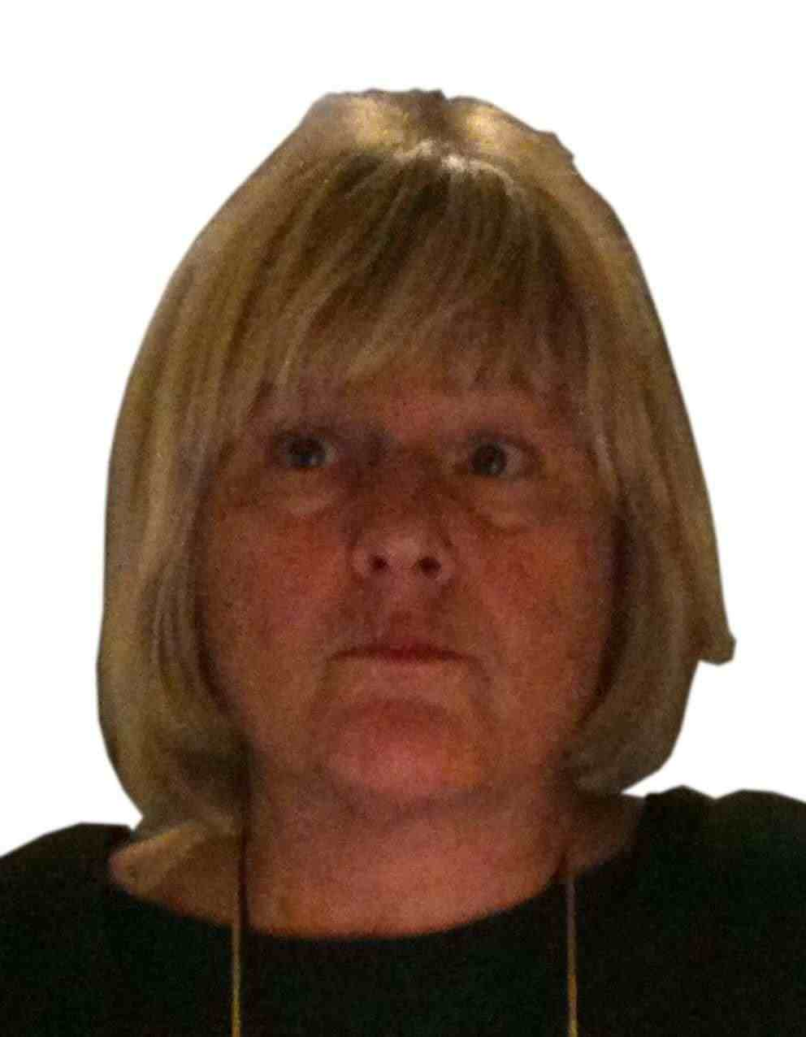

Curriculum Vitae Livia Bellina

Personal Informations:

Place and date of birth: Palermo, 25.8.1954 Country of Origin : Italy Address : Via Sciuti 180 90144 Palermo Italy e-Mail liviabellina@gmail.com local mobile +668 5909 8878 mobile +39 3389112818

Skype id liviamarcellaclaudia

General Informations

Language

Mother tongue Italian English spoken and written (basic) French spoken and written (basic)

Areas of Expertise (Keywords)

Rural health care, Diagnostic Pathology ,M-health , M-Education, Logic Clinic ,Education Training on the job, Global Health

Social skills and competences
Strongly values-led, inspirational, natural leader. Excellent communicator, naturally prone to network and establish new working and human relationships. Likes to build, and work with teams, motivating his collaborators. Easily adapts to multicultural, intergenerational and diverse social and economical environments. Thanks to attitude and open and communicative behaviour she easily establish a good human relation with patients, as well as students, teams and colleagues, as documented by several letters from Bangladeshi students, and thank to her work and ideative capacity and her strong commitment and personal networks she builds utility networks and often can see and solve local problems with appropriate, frugal , solutions for bridging the technological and educational gap http://www.mobilediagnosis.net Thanks to her strong determination , she manages to keep pace of work very hard to achieve the objectives

Organisational skills and competences Is an experienced teacher , wirh good experience in hard and rural contexts. Good Experience in networking and communicating with people . With long and passionate experience and engagement in education affairs, she developed good competence in establishing team motivated and working groups, and actively contributes to their growth and development. Is forward looking and enjoys innovation.

Computer skills and competences Good Knowledge of most popular office-software applications (in multiple platforms: Windows , Macintosh, Open Source), easiness to get familiar with new packages and tools.

Education and Training
After completing Classical Studies in Palermo, Educandato Maria Adelaide
1973-1979 . Degree in Medicine at Medical Faculty , Palermo University
1980-1983 . Post Graduate Specialization in General Pathology) Medical Faculty of Palermo University
1983 -1984 . PhD -Post Graduate Trainin in Immunopharmacology (one year )
2010-2012 . Master in Medicine of Migration . Marginalization and Poverty –Idente Foundation-Caritas –Rome

Short Training Courses
2008 – October, 12-25 Basic Laboratory for Tropical Disease -Don Calabria Hospital Negrar, Verona
2009 -March-June-Advanced Post Graduate Course of Tropical Medicine and International Health Cooperation-Careggi Hospital - University of Florence
2010 -July 26-August 6 Management of Programmes for Communicable Diseases Control in Sub-Saharianan Africa Foundation MPCDC 2010-Public Health Laboratory Ivo De Carneri Pemba Zanzibar

Medical Association-Academic Affiliation -Professional and Scientific Affiliations
Medical Association, since 1980
Italian Pathologist Association, since 1991
Italian Society of Migration Medicine (SIMM), since 2009
Italian Society of Tropical Medicine (SIMET), since 2009
National Focal Point Work Group “ European AIDS & Mobility Project “ COST Action(European Cooperation In Science and Technology ) since 25-06-2010 Euripa group until 17-12 2008
Anspi until October 2008
Pathologist OverBorder 2010
Union from September 2010
Global Health Workforce Alliance -GWHFA-WHO 2011‏
Ashoka Changemakers -Health Innovation Group 2012
M-Health Alliance 2013

Professional Experience -Academical Experiences and Research involvements

1974-1985 :Academic research and internships
1974-1979 Intern researcher student
1980-1983 Post graduate training in the Institute of General Pathology- Medical Faculty Palermo University
1980- Fellowship Research granted by CONI for research about Immunological depression in athletes
1981- Fellowship Research granted by CONI
1981-March-June - Full time Instructor in Laboratory Medicine, Medical University of South Carolina, Charleston, South Carolina (USA)
1981- “Cultore della Materia”(Adjunct Expert Professor) of General Immunology Medical Faculty Palermo University
1982- Adjunct Professor of General Immunology at the Microbiology post graduate Training - Medical Faculty Palermo University
1983- Reseach Doctorate in Immunopharmacology -Medical Faculty Palermo University
1983 -Medical Expert at the Dept. of Tissue Immunology – Medical Faculty Palermo University
1983 October,1st -December 31st

Professional Experience –Medicine
1985-Pathologist, medical laboratory, National Health Service, ASL 6, Civic Hospital Partinico, Palermo January 1st June 30
1987 until now Medical doctor , Specialist (general pathology) on the Territorial Districts of National Health System -National Health Service, ASP ( 1991- 2010 MD pathologist ,at district of Lampedusa Island )
Professional Experience – Experiences in Developing Countries –Training – Consulences -M-Health –Global Health- Health Rural Development
2009 (October-November) Medical Expert Supervisor of Main Lab and Teacher for Laboratory Technicians School – Saint Mary Hospital – Lacor-Gulu,Uganda. (Corti Foundation International Cooperation project)
2010 (April-July) Medical Expert and Teacher-Consultant for the Grameen Kalyan , Mohammad Yunus Foundation , in Dhaka, Bangladesh
2011-(February-May) Medical Expert and Teacher at St.Vincent Hospital Dinajpur-Bangladesh.
2011 (July - September ) Medical Expert and Supervisor o fMedical Laboratory of Childrness –Governative Hospital - Herat Afganistan (MAE Project –AISPO)
2012 Feb-March : Madagascar –Andavadoaka- Tulear- Medical Expert –Explorative Mission
MobileDiagnosis Association
2012 September-November –Medical Expert-Consultant and Teacher -Democratic Republic of
Congo-Tshimbulu –Western Kasai –St François Hospital
2013 February-March, April-June Coordinator and Expert Consultant at Yunus Center AIT Bangkok-Thailand
2013 May :Expert teacher and consultant at Mae sot SMRU_Oxford malaria Research Unit Mae Sot
Thailand

Conferences – Seminars -Workshops - and other Scientific Events of the last three years

2008 October 3-5 Congress of ANSPI Carloforte Sardinia Italy
2009 - February, 5- 7: VII Congress of Migration Medicine (SIMM) Trapani
2009 -April, 3-4: Equal Opportunities of Healt:Action to Development a Plan for Action to Teach and Advocate Global Health –International Conference On Global Health -Padova
2009 - June,4: Meeting of National Focal Point :Salute e Transculturalità :L’impegno scientifico ed il contributo operativo del National Focal Point Italiano-Dipartimento malattie infettive, parassitarie ed immunomediate – ISS
2009 -September 6-10 6th European Congress of Tropical Medicine and International Health and 1th Mediterranean Conference on Migration and Travel Health -Verona Italy with a presentation (Hetical and public health concerns based on retrospective analysis of referrals for diagnostic parasitology of immigrants and autochthonous population in Lampedusa island (Italy)- Bellina,l:Maugeri,M:Missoni,E:
2009 -October 1 st November 28 -Visiting Consultant Laboratory Doctor in Saint Mary Hospital,Lacor,..Gulu Uganda -for Supervision and Training of Laboratory Technologist,Technicians and Assistent and Teachin to Laboratory Assistent Training Scool
2010 -April 20 -July 20 MD, teacher and Consultant in Bangladesh, Grameen Kalyan central office -Dhaka and rural health center Comilla and Tangail-Bhuapur
2010- 41st Union World Conference on Lung Health which was held on 11-15 November 2010 in Berlin, Germany.
(Bellina L., Missoni E., Increasing connectivity of isolated health workers in poor countries using locally available technology. The International Journal of Tuberculosis and Lung Disease, 2010, 14, 11 suppl.2, pp. S46-S47)
2011-February-May Teacher and Consultant in Bangladesh-Dinajpur St.Vincent Missionary Hospital(PIME Organization)
2011-July to September Afganistan-Herat as Teacher and consultant for laboratory of Pediatric Hospital of Herat -Afgani Government with AISPO- Conference at General Hospital
2011 - 7th European Congress on Tropical Medicine & International Health 3-6 October, 2011.
Barcelona - Spain (Bellina,L:Missoni,E:MobileDiagnosis:an appropriate technology for tele
microscopy,an effective tool for training European Journal TM & IH vol 16,Supplement 1,October
2011,pag 88 www.blackwellpublishing.com/tmi)
2012-September Conference in Tshimbulu for CA of St François Hospital
2012 –November, 3 Conference in Kinshasa, for Country COE board
2012-November , 9 : III edizione del Convgno “le Malattie Infettive del Migrante e del Viaggiatore”
Ferrara 9 Novembre “MobileDiagnosis: Dalla telepatologia alla educazione-dalla emergenza ad un nuovo sistema educativo “ Livia Bellina
2013- Florence Careggi Main Lesson about : Tecnologia appropriata e nuove metodologie
di comunicazione per i paesi a risorse limitate : m health e MobileDiagnosis – June, 25- Medical University of Careggi - Course of Perfectionament / Master in Tropical Medicine and Cooperation

Selected Publications - last five years

Bellina, L,.Missoni, E. Mobile Diagnosis: Bridging Sociocultural Gaps and Empowering Women Telemedicine and e-Health November 2011, 17(9): 750-750. doi:10.1089/tmj.2011.9976. http://www.liebertonline.com/doi/abs/10.1089/tmj.2011.9976
Bellina, L., Missoni, E. Mobilephone image transmission for diagnosis. In: World Health Orgaization, Compendium of new and emerging health technologies, WHO/HSS/EHT/DIM/11.02, Geneva, 2011
Bellina,L:Missoni,E:MobileDiagnosis:an appropriate technology for tele-microscopy,an effective tool for training European Journal TM & IH vol 16,Supplement 1,October 2011,pag 88 www.blackwellpublishing.com/tmi
Bellina,LMissoni,E:M-learning: mobile phones’ appropriateness and potential for the training of laboratory technicians in limited-resource settings- Health and Technology 2011 October , DOI: 10.1007/s12553-011-0008 http://www.springerlink.com/content/a328n117r7775322/

Bellina,L In Good Practice-Mobile Diagnosis : The Grapevine -Summer Euripa Magazine
[PDF] The Grapevine www.euripa.org/.../GrapevineSummer11.pdf

Bellina,L:MobileDiagnosis, in Good Pratice-2011,July Freedom From Want(MDGC-AIT)
http://issuu.com/arcmdg/docs/aw_ffw2_final
Bellina L., Missoni E., Increasing connectivity of isolated health workers in poor countries using locally available technology. The International Journal of Tuberculosis and Lung Disease, 2010, 14, 11 suppl.2, pp. S46-S47
Bellina.L:Maugeri,M:Missoni,E:Hetical and public health concerns based on retrospective analysis of referrals for diagnostic parasitology of immigrants and autochthonous population in Lampedusa island (Italy)- European Journal TM & IH vol 14,Supplement 2,Sepotember 2009,pag 66 www.blackwellpublishing.com/tmi
Bellina, L., Missoni, E., Mobile cell-phones (M-phones) in telemicroscopy: increasing connectivity of isolated laboratories, Diagnostic Pathology, 2009, 4: 19 http://www.ncbi.nlm.nih.gov/pmc/articles/PMC2706795/
Grameen Kalyan :Training on Diagnostic Pathology 07-10 june 2010 Tutorial Book of Course for Healthworkers trained by Dr Livia Bellina ,assisted by Dr Baqui Supported by Regional Office Comilla Venue:Rajapur Health Center ,Comilla Unpublished
Previous Publications
Caruso, A., Bellina, L., B8, DR3 antigens and production of human leucocyte migration inhibitory factor (LIF) by mononuclear cells stimulated with concanaval A Tissue Antigens. 1983, Aug; 22(2):167-9. B8, DR3 antigens and production of human leucocyte migration inhibitory factor (LIF) by mononuclear cells stimulated with concanavalin
Cillari E, Lio D, Bellina L, Caruso C, Brai M, Natoli D., Lymphocyte subsets in hereditary angioedema, Ann Sclavo. 1982 Nov-Dec;24(6):666-75. Lymphocyte subsets in hereditary angioedema.

Bellina L, Salerno A., Chicken buffy coat leucocytes (BCL) as indicator cells for human leucocytes migration inhibitory factor (LIF), J Immunol Methods. 1981;43(3):277-81. Chicken buffy coat leucocytes (BCL) as indicator cells for human leucocytes migration inhibitory factor (LIF).

Caruso C, Palmeri P, Dieli F, Bellina L, Benvegna S, Cillari E, Salerno A., Depression of contact sensitivity to oxazolone by the paramyxovirus of Newcastle disease. Impairment by infectious virus of effector T cells which mediate the response to contactant, Int Arch Allergy Appl Immunol. 1981;66(1):91-9. Depression of contact sensitivity to oxazolone by the paramyxovirus of Newcastle disease. Impairment by infectious virus of effector T cells which mediate the response to contactant.

Caruso C, Bellavia A, Bellina L, Salerno A., Delayed-type skin reactions in bursectomized or thymectomized chickens, Experientia. 1977 Aug 15;33(8):1105-6. Delayed-type skin reactions in bursectomized or thymectomized chickens.

Patent and Other Activities

2008- Patent m-health : - Italian and European Patent Office
“ System for take and use, share a send images from microscopical field without any device” (MobileDiagnosis )
The described method has been filed for patent in April 2008, with the sole purpose to protect the idea from commercialization and consent its free use and dissemination. ( EPO application number 09005054.3 2002 - 2008 April )
http://www.patsnap.com/patents/view/EP2116884A1.html

2009-Website : website to help those who need diagnostic confirmation: http://www.mobilediagnosis.net

2010-Foundation of MobileDiagnosis Association “MobileDiagnosis”association for the Global Access to Care, diagnostic support and Education http://www.mobilediagnosis.net

2011 MobileDiagnosis became a non-profit Association The Association . MobileDiagnosis has been recognized by the Government in November 2011, 28 as a No Profit -Association (Government number 97261360826 )

2012- The Bellagio Initiative, of Rockefeller Foundation, published “MobileDiagnosis Mobile Project” on The Bellagio Initiative
”The Future of Philantropy and Development in the Pursuit of Human Wellbeing”
as Innovation, Health,Technology and Education
http://www.bellagioinitiative.org/resource-section/your-ideas/innovations/innovations-bank/

2012: Pre-agreement Partnership with Asian Institute of Technology - Yunus Centers
http://pwl.ait.asia/index.php/archives/show/651 for a common project for Rural Communities of Asian Regions

Present Research Interests and Involvements

Psychological basis of the learning mechanism and m-phone application
Appropriate technology and rural development
Economic models for health care and rural development
Social Business Model and M-Technology for Health Care in Rural Community

Prizes and Awards

2011- Ashoka Challange -selected as one of the top 30 finalists of the Challenge “Top 11 in 2011 Innovators “
2012- Premio Rosario La Duca, a life for Palermo -Rotary Inner Wheel, Palermo Centro, jointed with University Academic Board for commitment and work made on the fields of health care support and education in Developing Countries
2012- Ashoka Changemaker admission in Ashoka Health Innovator Group a network of health global innovator

Useful Links
http://www.patsnap.com/patents/view/EP2116884A1.html
http://www.who.int/medical_devices/innovation/new_emerging_tech_10final .pdf http://www.who.int/workforcealliance/members_partners/member_list/mobil ediagnosis/en/index.html http://www.bellagioinitiative.org/innovations/mobile-diagnosis-mobile- project/ http://www.healthunbound.org/content/mobilediagnosis-global-project- based-most-relevant- technology-brain http://www.mhealthalliance.org/membership-info

2013-03-16
Livia Bellina


